Supplementary Fig. 1. FOXM1 and CEP55 are significantly upregulated and positively correlated in HNSCC tissues.
(A-B) Box plots showing the mRNA expression levels (log2[TPM + 1]) of FOXM1 (A) and CEP55 (B) in tumor tissues versus adjacent normal tissues from the TCGA-HNSC dataset. Statistical significance was determined by Wilcoxon rank-sum test because the TCGA-HNSC expression data did not follow a normal distribution (Shapiro-Wilk test, P < 0.001), the non-parametric Wilcoxon rank-sum test was applied. (C) Scatter plot showing the Spearman correlation between FOXM1 and CEP55 mRNA expression in HNSCC tumor samples. The black line represents the linear regression fit, and the shaded area indicates the 95% confidence interval.
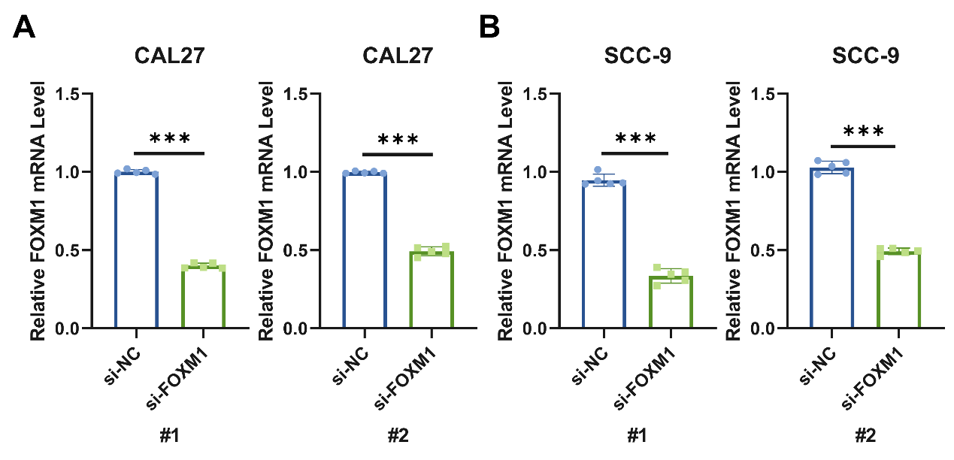
Supplementary Fig. 2. Validation of FOXM1 siRNA knockdown efficiency.
(A-B) qRT-PCR analysis of FOXM1 mRNA expression in CAL27 (A) and SCC-9 (B) cells transfected with si-NC, si-FOXM1#1, or si-FOXM1#2 for 48 h. Data are presented as mean ± SD with individual data points (n=5). ***P < 0.001.

